BIOLOGY

Insert School Logo

UNITS 3 & 4

2021

Name:

Teacher:

Time allowed for this paper
Reading time before commencing work: ten minutes
Working time: three hours

Materials required/recommended for this paper
To be provided by the supervisor
This Question/Answer booklet
Multiple-choice answer sheet

To be provided by the candidate
Standard items: pens (blue/black preferred), pencils (including coloured), sharpener, correction fluid/tape, eraser, ruler, highlighters
Special items: non-programmable calculators approved for use in this examination

Important note to candidates
No other items may be taken into the examination room. It is your responsibility to ensure that
you do not have any unauthorised material. If you have any unauthorised material with you, hand
it to the supervisor before reading any further.

Structure of this paper

Section | Number of questions available | Number of questions to be answered | Suggested working time (minutes) | Marks available | Percentage of examination
Section One  Multiple-choice | 30 | 30 | 40 | 30 | 30
Section Two  Short answer | 5 | 5 | 90 | 100 | 50
Section Three  Extended answer  Part A | 2 | 1 | 50 | 40 | 20
Part B | 2 | 1
 |  |  |  | Total | 100

Instructions to candidates

1. The rules for the conduct of the Western Australian external examinations are detailed in the Year 12 Information Handbook 2021. Sitting this examination implies that you agree to abide by these rules.

2. Write your answers in this Question/Answer booklet preferably using a blue/black pen. Do not use erasable or gel pens.

3. Answer the questions according to the following instructions.

Section One: Answer all questions on the separate Multiple-choice answer sheet provided. For each question, shade the box to indicate your answer. Use only a blue or black pen to shade the boxes. Do not use erasable or gel pens. If you make a mistake, place a cross through that square, then shade your new answer. Do not erase or use correction fluid/tape. Marks will not be deducted for incorrect answers. No marks will be given if more than one answer is completed for any question.

Section Two: Write your answers in this Question/Answer booklet. Wherever possible, confine your answers to the line spaces provided.

Section Three: Consists of two parts each with two questions. You must answer one question from each part. Tick the box next to the question you are answering. Write your answers in this Question/Answer booklet.

4. You must be careful to confine your answers to the specific questions asked and to follow any instructions that are specific to a particular question.

5. Supplementary pages for planning/continuing your answers to questions are provided at the end of this Question/Answer booklet. If you use these pages to continue an answer, indicate at the original answer where the answer is continued, i.e. give the page number.

Section One: Multiple-choice 30% (30 Marks)

This section has 30 questions. Answer all questions on the separate Multiple-choice answer sheet provided. For each question, shade a box to indicate your answer. Use only a blue or black pen to shade the boxes. Do not use erasable or gel pens. If you make a mistake, place a cross through that square, then shade your new answer. Do not erase or use correction fluid/tape. Marks will not be deducted for incorrect answers. No marks will be given if more than one answer is completed for any question.

Suggested working time: 40 minutes.

1. An organism with the potential to cause disease is known as a

(a) bacteria.
(b) pathogen.
(c) parasite.
(d) virus.

2. If 20% of the bases in a DNA molecule are thymine, the percentage of cytosine will be

(a) 20%
(b) 30%
(c) 60%
(d) 80%

3. Semi-conservative replication of DNA refers to

(a) the synthesis of DNA from selected chromosomes in the nucleus.
(b) the antiparallel nature of complementary DNA strands.
(c) the synthesis of a new DNA molecule comprising one parent strand and one daughter strand.
(d) the formation of hydrogen bonds between newly synthesised DNA strands.

4. An anticodon

(a) initiates translation.
(b) is read in a 5' to 3' direction.
(c) is complementary to the original DNA sequence.
(d) is complementary to a corresponding mRNA codon.

5. The presence of gill slits in a human embryo suggests that humans

(a) once inhabited aquatic ecosystems.
(b) have previously used gills to breathe.
(c) share a common ancestor with fish.
(d) share a common ancestor with whales.

Use the information below to answer question 6.

Population A - low numbers
Population B - high numbers
Population C - low genetic diversity
Population D - high genetic diversity

6. Which of the populations listed above would be most susceptible to the effects of genetic drift?

(a) A and D
(b) A and C
(c) B and C
(d) B and D

7. Agrobacterium tumefaciens is a soil bacterium that causes

(a) dieback.
(b) tetanus.
(c) Ross River virus.
(d) Crown gall disease.

8. Captive breeding is an effective conservation tool used by biologists to aid the recovery of vulnerable native populations. Which of the following is not an intentional outcome of captive breeding?

(a) increased genetic diversity
(b) increased gene flow
(c) expansion of geographical range
(d) greater population numbers

9. A gene pool represents

(a) the total number of genes present in a given population.
(b) all the different alleles present in a given population.
(c) the phenotypic variation within a given population.
(d) the number of individuals present in a given population.

10. In a particular species of plant, dark blue flowers are dominant over light blue flowers. A homozygous dominant plant (BB) is pollinated by a homozygous recessive plant (bb). The resulting F₁ offspring were then interbred. What is the genotypic frequency of the F₂ generation?

(a) 25 % BB, 25 % bb and 50 % Bb
(b) 50 % BB and 50 % bb
(c) 50 % BB and 50 % Bb
(d) 100 % Bb

11. Which of the following statements is true regarding a genetic disease that is X-linked recessive?

(a) only male offspring are affected
(b) only female offspring are affected
(c) it is inherited from the female parent only
(d) it can be inherited from both male and female parents

Questions 12 and 13 relate to the information below.

A new species of Orangutan has been confirmed using fossils and genomic comparisons. Pongo tapanuliensis, or the Tapanuli Orangutan, is found in an isolated pocket of northwest Sumatra, in an area of around 1000 km². There are approximately 800 individuals remaining, making the Tapanuli Orangutan the most critically endangered primate on Earth. A more recent phylogenetic investigation has mapped the evolution of the three Orangutan species after their ancestral species split from the other great apes around 14 million years ago. The Tapanuli Orangutan split from its ancestral species approximately 3.4 million years ago, with the Sumatran Orangutan and the Bornean Orangutan diverging around 674,000 years ago.

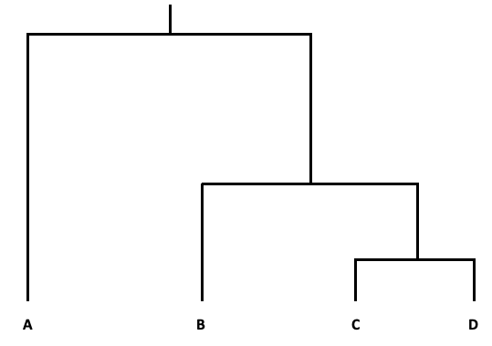
14 mya

Present

12. Given this information, which position on the phylogenetic tree shown above represents the newly discovered Tapanuli Orangutan?

(a) A.
(b) B.
(c) C.
(d) D.

13. It has been suggested that the divergence of the Bornean and Sumatran Orangutans was influenced by rising sea levels due to the melting of polar ice. This divergence is most likely an example of

(a) adaptive radiation.
(b) sympatric speciation.
(c) allopatric speciation.
(d) convergent evolution.

Question 14 relates to the information below.

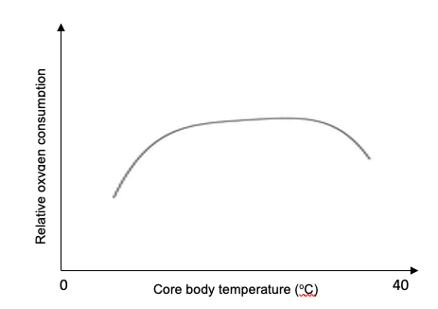
Relative oxygen consumption

Core body temperature (ºC)

14. The data presented in the graph shown above most likely represents the metabolic activity of a

(a) marsupial.
(b) whale.
(c) fish.
(d) bird.

15. A gradual change in allelic frequency of a given population is usually the result of

(a) inbreeding.
(b) an increase in selective pressures.
(c) genetic engineering.
(d) artificial selection.

16. Polygenic inheritance is characterised by

(a) discrete phenotypic variation.
(b) continuous phenotypic variation.
(c) a genotype greater than 2n.
(d) a greater degree of allelic heterogeneity.

17. Fossils provide evidence for evolution because they

(a) show that all living organisms share the same genetic material.
(b) represent the preserved remains of every living organism that has ever lived on Earth.
(c) suggest that life has existed on Earth for billions of years.
(d) reveal the anatomical links between extinct aquatic and terrestrial animals.

18. The measles virus has a high rate of infectivity, meaning that

(a) symptoms develop rapidly.
(b) it is easily spread amongst hosts.
(c) it has a long incubation period.
(d) it is incurable.

19. Familial hypercholesterolaemia is a genetic disorder that results in high levels of cholesterol in the blood and is the main cause of coronary heart disease in people under the age of 55. This disorder is caused by the substitution of a single nucleotide in a gene associated with blood-cholesterol regulation. The mutation does not change length of the gene.

Given this information, the mutation causing familial hypercholesterolaemia can be categorised as a

(a) nonsense mutation.
(b) missense mutation.
(c) silent mutation.
(d) frameshift mutation.

20. Covid-19 is zoonotic and caused by the SARS-CoV-2 virus. Zoonotic viruses can be particularly dangerous because they

(a) have a high mortality rate.
(b) can be transferred between mammal species.
(c) can be transferred between different vertebrate species.
(d) are always highly virulent.

21. Convergent evolution is characterised by

(a) homologous structures.
(b) analogous structures.
(c) common ancestry.
(d) fixation of allelic frequencies.

22. The stomata of some xerophytic plants are in sunken pits. Which of the following best describes the function of sunken pits?

(a) protection of the stomata from damage by insects
(b) increasing the surface area of the leaf to allow for increased gas exchange
(c) creating a moist air pocket which helps to increase the rate of transpiration
(d) creating a moist pocket of air which decreases the rate of transpiration

23. A long loop of Henle may be present in the kidneys of animals that live in

(a) freshwater habitats.
(b) marine habitats.
(c) the rainforest.
(d) arid regions.

Question 24 relates to the image below.

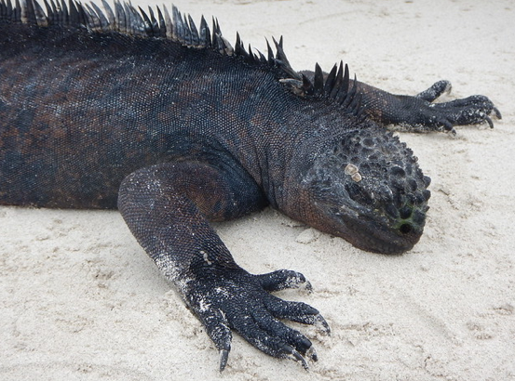

24. The marine iguana (Amblyrhynchus cristatus), shown in the image above, has dark- coloured skin. This adaptation helps the iguana thermoregulate via

(a) conduction.
(b) convection.
(c) radiation.
(d) vasodilation.

25. With age, skin cells produce less collagen, a structural protein, which leads to the appearance of wrinkles. Retinoic acid is a skin treatment that stimulates the skin cells to produce more collagen.

Given this information, which of the following cellular activities is retinoic acid most likely to influence?

(a) mitosis
(b) transcription
(c) cell apoptosis
(d) meiosis

26. In 1959, American horticultural scientists used x-rays and irradiation to produce grapefruit with red flesh and fewer seeds. These changes in grapefruit phenotype are most likely the result of

(a) the suppression of dominant traits.
(b) a decrease in genetic mutations.
(c) an increase in genetic mutations.
(d) stimulating transcription of genes already present in the grapefruit genome.

27. Controlling variables in an experiment is important because it

(a) allows data to be recorded with more precision.
(b) allows the independent variable to be controlled.
(c) improves the validity of the data collected.
(d) improves the reliability of the data collected.

28. Homeostasis can only be maintained if an organism can respond to changes in external or internal stimuli. Which of the following represents a change in internal stimuli of a tropical marine fish?

(a) a reduction in water temperature
(b) an increase in dissolved oxygen in the water
(c) an increase in urine excretion
(d) an increase in blood ammonia levels

29. Which of the following best describes the defining feature of the negative feedback mechanism of homeostasis?

(a) the outcome is opposite to the input.
(b) the outcome is an amplification of the input.
(c) it is controlled by the nervous system.
(d) a constant internal environment is always maintained.

30. Malaria is an infectious disease found mostly in tropical climates. Illness in humans is caused by microorganisms from the genus Plasmodium which is transmitted from host to host via

(a) human saliva.
(b) contaminated water.
(c) a vector.
(d) a parasite.

End of Section One

Section Two: Short answer 50% (100 Marks)

This section has five questions. Answer all questions. Write your answers in the spaces provided.

Supplementary pages for planning/continuing your answers to questions are provided at the end of this Question/Answer booklet. If you use these pages to continue an answer, indicate at the original answer where the answer is continued, i.e. give the page number.

Suggested working time: 90 minutes.

Question 31 (20 marks)

(a) Compare two major structural differences between a bacterium and a virus. (2 marks)

One: Two:

(b) Explain why bacteria can be easily cultured in a petri dish for research purposes while viruses cannot. (4 marks)

(c) Explain how disease-causing bacteria evolve resistance to antibiotics. (4 marks)

(d) Explain the transmission of pathogens via

(i) Direct contact (2 marks)

(ii) Indirect contact (2 marks)

Allowing travellers to return home to Australia during the Covid-19 pandemic presents some major concerns for health authorities. While vaccination programs are underway, new variant strains of SARS-CoV-2 have emerged in other countries including the UK, South Africa and India.

(e) Explain why the emergence of variant strains occurs more frequently in countries with large populations. (2 marks)

Effective vaccination programs are crucial to the maintenance of herd immunity.

(f) Explain the importance of vaccination in increasing herd immunity in the control of infectious disease. (4 marks)

Question 32 (20 marks)

Emperor penguins (Aptenoytes fosteri) breed during the Antarctic winters, enduring extreme weather conditions. Male penguins may spend up to four months of the year incubating a single egg while the females hunt for food. During this period, the male penguins do not feed and must keep the egg warm at all times. To withstand the freezing temperatures (-40ºC) and damaging winds of up to 200 km/h, the male penguins form tight huddles and routinely rotate their positions from the outside of the huddle to the inside. This behaviour has shown to help maintain an ambient air temperature of up to 24ºC at the centre of the huddle.

A biology class was investigating the effect of huddling on temperature regulation. The students wanted to find out whether the size of a penguin huddle has an effect on maintaining a relatively constant temperature within the huddle. This would be determined by measuring any change in temperature of different sized huddles, over a given period of time.

Three separate 'huddles' were set up using test tubes filled with warm water. Huddle one was represented by a single test tube, while huddles two and three contained 12 and 24 test tubes, respectively. Each test tube contained a thermometer and 10 mL of 40ºC water and stoppered with cotton wool. The test tube huddles were held together with a strip of cling film and placed on a wooden stand. The room temperature was recorded at 21ºC. All windows and doors were shut, and the lights and air conditioning were turned off. Water temperature of every test tube was recorded intermittently over a 45-minute period and an average calculated.

(a) Identify the independent and dependent variables in this experiment. (2 marks)

Independent

Dependent

(b) Suggest a suitable hypothesis for this experiment. (2 marks)

The results of the investigation are summarised in the table below.

Table 1: Change in mean water temperature (ºC) of the test tube 'huddles' over time.

Time (mins) | Mean water temperature (ºC)
 | Huddle 1 | Huddle 2 | Huddle 3
0 | 40 | 40 | 40
5 | 35 | 38 | 39
10 | 32 | 37 | 39
15 | 29 | 36 | 38
20 | 25 | 35 | 37
25 | 24 | 35 | 37
30 | 23 | 33 | 36
35 | 22 | 31 | 35
40 | 21 | 29 | 34
45 | 21 | 27 | 34

(c) Construct a graph of the data from Table 1 in the grid provided below. (6 marks)



A spare grid is provided at the end of this Question/Answer booklet. If you need to use it, cross out this attempt and indicate clearly that you have redrawn it on the spare page.
(d) Using the information presented in the graph, explain the results obtained for each test tube huddle. (6 marks)

(e) State one change that could be made to the experimental design and explain how it could better represent penguin behaviour or environment. (2 marks)

(f) State one change that could be made to the experimental design and explain how it improves the reliability of the data. (2 marks)

Question 33 (20 marks)

(a) Identify the differences between DNA and RNA by completing the table below.
(3 marks)

Feature | DNA | RNA
Sugar
Bases
Strands

(b) Describe the function of the following RNA molecules.

(i) mRNA (2 marks)

(ii) tRNA (2 marks)

(c) Explain why more than one molecule of a particular protein can be synthesised from a single transcribed mRNA molecule. (3 marks)

The diagram below represents a simplified version of DNA replication.

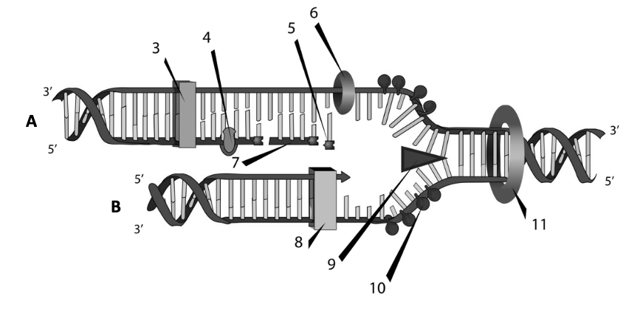

(d) Using the diagram, identify the following structures and their role in DNA replication. (4 marks)

Structure | Name | Role
8
9
(e) Describe how DNA replication differs between strand A and strand B. (6 marks)

Question 34 (20 marks)

A scuba diver wanted to start a collection of small marine fish in his home aquarium. After obtaining several specimens during a reef dive, he carefully transported them home and transferred them into the aquarium that contained freshwater. By the next morning, all the fish were dead.

(a) Explain why marine fish cannot survive in freshwater. (4 marks)

Thermoregulation is crucial to the survival of all animals as normal cellular activities will only occur within specific internal temperature ranges.

(b) Describe the difference between an endotherm and an ectotherm. (4 marks)

(c) Suggest two benefits of being ectothermic. (2 marks)

One:
Two:

(d) Explain how the following adaptations enable an endotherm to regulate its body temperature.

(i) Subcutaneous fat/blubber (2 marks)

(ii) Counter-current exchange (2 marks)

(iii) Vasoconstriction (2 marks)

Many Australian marsupials live in arid regions and experience large fluctuations in environmental temperatures.

(e) Identify two behavioural adaptations of marsupials living in arid regions and explain how these adaptations help them to survive. (4 marks)

One:

Two:

Question 35 (20 marks)

Developments in biotechnology have changed the way scientists approach almost every aspect of research in heredity.

(a) For each of the following scenarios, identify the applicable biotechnology method needed to carry out the described process. (4 marks)

Scenario | Method
DNA fingerprinting
Determining ancestral relatedness between species
Synthesis of large volumes of DNA
Measuring expression levels of a disease-causing gene

(b) Define the term 'short tandem repeat'. (2 marks)

(c) Explain why short tandem repeats (STRs) are used in human DNA profiling. (3 marks)

The development of transgenic organisms has enabled significant advances in the pharmaceutical and agricultural industries around the world.

(d) Define 'transgenic organism'. (1 mark)

The development of transgenic organisms is reliant on the use vectors to transfer genetic information.

(f) Suggest two characteristics of bacterial plasmids that make them useful gene vectors. (2 marks)

One:
Two:

(e) Identify one application of transgenic technology to agriculture and explain its benefits. (2 marks)

(g) Construct a simple flow diagram to show the sequence of events that will result in the formation of a transgenic plant cell. (6 marks)

End of Section Two

Section Three: Extended answer 20% (40 marks)

Section Three consists of four questions.

Questions 36 and 37 are from Unit 3. Questions 38 and 39 are from Unit 4. Answer one question from Unit 3 and one question from Unit 4.

Use black or blue pen for this section. Do not use erasable or gel pens. Only graphs and diagrams may be drawn in pencil. Responses can include; labelled diagrams with explanatory notes; lists of points with linking sentences; labelled tables and/or graphs; and/or annotated flow diagrams with introductory notes.

Supplementary pages for planning/continuing your answers to questions are provided at the end of this Question/Answer booklet. If you use these pages to continue an answer, indicate at the original answer where the answer is continued, i.e. give the page number.

Suggested working time: 50 minutes

Unit 3

Choose either Question 36 or Question 37.

Indicate the question you will answer by ticking the box next to the question. Write your answer on pages 26 - 29. When you have answered your first question, turn to page 30 and indicate on that page the second question you will answer.

Question 36 (20 marks)

(a) Describe the processes involved in converting the DNA code in a gene into a polypeptide.
(10 marks)

(b) Compare the concepts of microevolution and macroevolution. Use examples to support your answer.
(10 marks)

Question 37 (20 marks)

(a) Explain how sexual reproduction increases the genetic diversity of a species. (10 marks)

(b) Discuss natural selection and genetic drift as mechanisms for evolution.
(10 marks)

Question number:

Question number:

Question number:

Question number:

Unit 4

Choose either Question 38 or Question 39.

Indicate the question you will answer by ticking the box next to the question. Write your answer on the pages provided.

Question 38 (20 marks)

(a) Discuss the three different types of nitrogenous waste produced by vertebrates and how it relates to the environment in which they live. Use examples to support your response.
(10 marks)

Chytridiomycosis, caused by the amphibian chytrid fungus Batrachochytrium dendrobatidis, is an infectious disease affecting amphibians on a global scale. Chytridiomycosis has been responsible for the rapid extinction of many species since the 1990s.

(b) Describe the lifecycle of the amphibian chytrid fungus. In your response, describe how infection with this pathogen affects an amphibian species.
(10 marks)

Question 39 (20 marks)

(a) Explain the structural and physiological adaptations of halophytes that allow them to thrive where other plants cannot.
(10 marks)

(b) Discuss the biology, transmission of and treatment for Tuberculosis (TB). In your response, explain why cases of TB in Australia are rare. (10 marks)

End of questions

Question number:

Question number:
Question number:

Question number:

Supplementary page
Question number:

Supplementary page
Question number:

Spare grid



ACKNOWLEDGEMENTS

Question 14
Graph - oxygen consumption vs core body temperature.
Author constructed

Question 24
Marine Iguana image - Constanza S. Mora
https://www.flickr.com/photos/28788207@N04/47765966752

Question 33 (d) and (e)
Diagram of DNA replication.
Wikimedia commons - public domain.
Mariana Ruiz.

